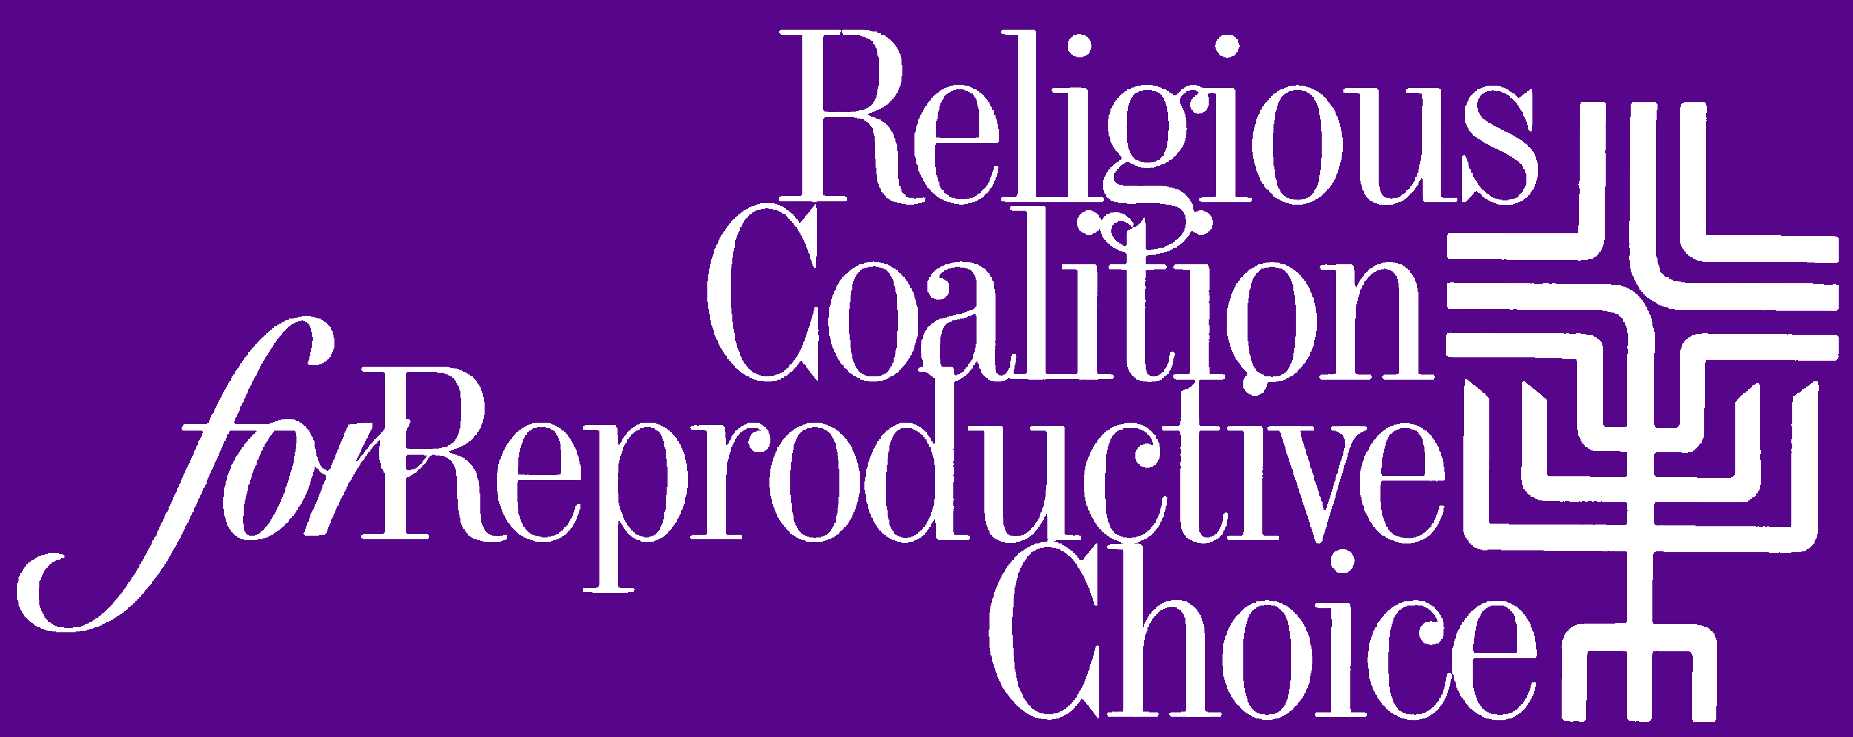

CONTACT:
Mollie Katz
240-338-3271
mkatz@rcrc.org

STATEMENT ON THIS WEEK’S SUPREME COURT NEWS
June 26, 2018

News from the U.S. Supreme Court this week has left many heavy hearts in our interfaith movement for reproductive health, rights and justice.

We’re appalled by the Court’s decision to let crisis pregnancy centers continue lying to women in the name of faith. We’re dismayed that the vacancy created by Justice Anthony Kennedy’s retirement will make it easier for those who promote the religious beliefs of conservative Christians to impede justice for all people, and exact harsh limits on reproductive freedom, particularly for poor and rural women, women with disabilities, and women of color. And we are morally outraged that the Court has let stand an immigration policy so clearly rooted in religious supremacy, racism, and xenophobia.

These and other escalating trends in the United States signal a dangerous reinforcing of values that take our nation farther away from compassion, dignity and respect for every person.

Rooted in the belief that all people are created in the image of God and all people are equal, RCRC’s values aren’t changing at all. Our values continue to fortify us and propel us in the prophetic work of protecting and respecting the dignity of all, especially women, families, people of color, immigrants, LGBTQ people, people with disabilities, and poor people. Our values call us to pray, stand and work united with individuals and groups committed to rebuilding a moral voice for justice.

